Hibernate Architecture

The Hibernate architecture includes many objects persistent object, session factory, transaction factory, connection factory, session, transaction etc.

There are 4 layers in hibernate architecture java application layer, hibernate framework layer, backhand api layer and database layer.Let's see the diagram of hibernate architecture:

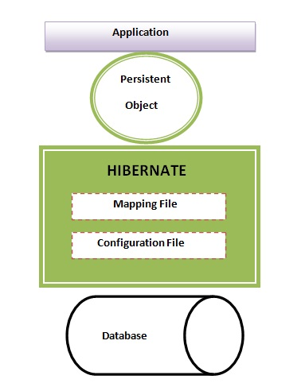

This is the high level architecture of Hibernate with mapping file and configuration file.

This is the high level architecture of Hibernate with mapping file and configuration file.

<p>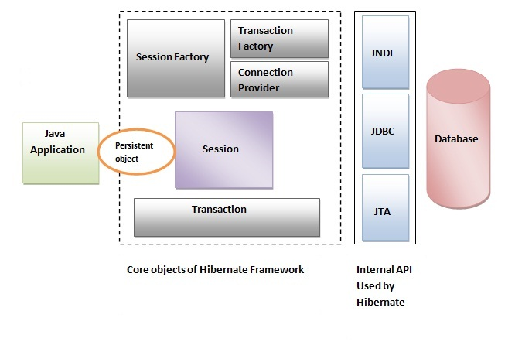

Hibernate framework uses many objects session factory, session, transaction etc. alongwith existing Java API such as JDBC (Java Database Connectivity), JTA (Java Transaction API) and JNDI (Java Naming Directory Interface).

### Elements of Hibernate Architecture

|  |
| --- |
| For creating the first hibernate application, we must know the elements of Hibernate architecture. They are as follows: |

#### SessionFactory

The SessionFactory is a factory of session and client of ConnectionProvider. It holds second level cache (optional) of data. The org.hibernate.SessionFactory interface provides factory method to get the object of Session.

#### Session

The session object provides an interface between the application and data stored in the database. It is a short-lived object and wraps the JDBC connection. It is factory of Transaction, Query and Criteria. It holds a first-level cache (mandatory) of data. The org.hibernate.Session interface provides methods to insert, update and delete the object. It also provides factory methods for Transaction, Query and Criteria.

#### Transaction

The transaction object specifies the atomic unit of work. It is optional. The org.hibernate.Transaction interface provides methods for transaction management.

#### ConnectionProvider

It is a factory of JDBC connections. It abstracts the application from DriverManager or DataSource. It is optional.

#### TransactionFactory

It is a factory of Transaction. It is optional.